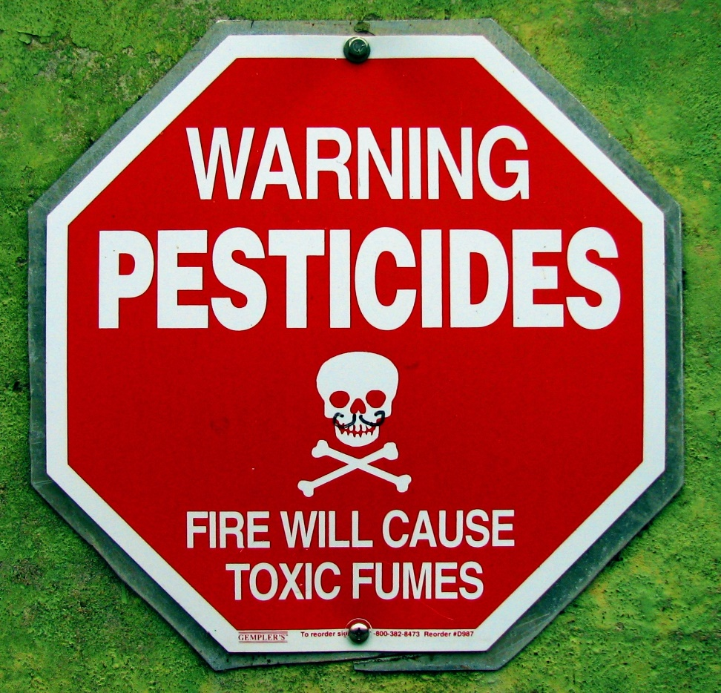
Qskeptics

Environmental Toxicology

Are we drowning in a sea of toxic chemicals?
Prof Matti Lang
National Research Centre for Environmental Toxicology UQ
There are many powerful lobbies involved in environmental toxicology. Societal attitudes vary from the Nimbin type ‘Earth Society’ (the ideation of community) as a lifestyle where children are raised like free range chickens, to the dogged, remorseless destruction of the “traditional” for white box housing and the ephemeral pursuit of everything modern. Many beautiful places only survive because of poverty and isolation. Many traditional places are decrepit, dirty, unsanitary and unhealthy. We love them (as in traditional Tibet) but loath the cardboard and plastic new world that replaces them.
Agriculture, health and industry demand the use of toxic chemicals. Either we want none of it (the organic movement) or all of it with GM and the lavish application of chemical controls of pesticides, herbicides and fertilisers. Throw in our medical exposure to powerful biological control agents, exposure to chemicals in our houses and illicit drugs and we have a bizarre cocktail of toxic chemicals, hormones and heavy metals saturating our world. There is of course the occasional catastrophic release of toxic chemicals that destroys whole cultures eg 1000km of the Ok Tedi and Fly rivers. Wiki details thousands of chemical disasters!
The more we rely on artificial interventions in mono cultures (eg chemicals, not birds, to control insects) we invite more and more long term unknowns. Toxic chemicals however, are released in Australia under very strict controls and maybe our concerns are overblown; PET and 2.4.D may do very little damage at all. PCBs and dioxins however, are persistent and concentrate in the food chain. After all the agonising how do we actually know what is harmful and what is not? We always knew lead in petrol was deadly but only now is the lead-count being taken in Mt Isa*. Could the entire city become Queensland’s Chernobyl?
Monday 26th September 2016
The Morrison Hotel
640 Stanley St, Woolloongabba QLD (07-3391 1413)
https://www.morrisonhotel.com.au/dining
6pm Dinner 7:30pm meeting (Piano Room)
* Eat breakfast Remember to eat breakfast in Mt Isa. A child who does not eat particularly after fasting (e.g. sleeping) can absorb considerably more lead than a child who has eaten. (Official response!)

